GROUP FIVE APE
NUMERICAL METHODS ASSIGNMENT
NAME | REG. NO.
MASIKA ELVIN FORTUNATE | BU/UP/2025/1969
AHAISIBWE CATHERINE | BU/UP/2025/1967
MUGALULA ABDUL | BU/UP/2025/3127
AKELLO JULIET | BU/UP/2025/5985
HAUMBA BENON | BU/UP/2025/5115

1. Introduction
This assignment presents MATLAB implementations of the Secant Method, Newton–Raphson Method and fourth-order Runge–Kutta (RK4) Method. The numerical examples are the same examples used in the previous Numerical Analysis work. The main change in this version is that the calculations are implemented using MATLAB functions rather than only ordinary scripts. Both for-loop and while-loop implementations are provided.
MATLAB anonymous functions are used to define the equations, while local functions implement the numerical algorithms. Flowcharts and pseudocode are also included for each method.

2. MATLAB Function Approach Used
Function type | Use in this assignment
Main function | Starts the assignment and calls the numerical-method functions.
Local function | Contains each numerical method and keeps the program organized.
Anonymous function | Defines equations such as f(x) = x³ − x − 2 and f(x,y) = x + y.
Nested function | Not required for these three numerical methods.
Private function | Not required for these three numerical methods.
Recursive function | Not appropriate for these iterative numerical methods.
Class method | Not required for this assignment.
Callback function | Not required because no GUI/event application is being developed.

3. Newton–Raphson Method

3.1 Question
Solve f(x) = x³ − x − 2 using the Newton–Raphson method, starting with x₀ = 1.5 and using a tolerance of 0.0001.

3.2 Principle and Formula
The Newton–Raphson iteration formula is:
xₙ₊₁ = xₙ − f(xₙ) / f′(xₙ)
For the given equation:
f(x) = x³ − x − 2
f′(x) = 3x² − 1

3.3 Step-by-Step Calculation
Iteration 1: xₙ = 1.500000. Substituting into xₙ₊₁ = xₙ − f(xₙ)/f′(xₙ) gives xₙ₊₁ = 1.521739. The absolute error is |xₙ₊₁ − xₙ| = 0.021739.
Iteration 2: xₙ = 1.521739. Substituting into xₙ₊₁ = xₙ − f(xₙ)/f′(xₙ) gives xₙ₊₁ = 1.521380. The absolute error is |xₙ₊₁ − xₙ| = 0.000359.
Iteration 3: xₙ = 1.521380. Substituting into xₙ₊₁ = xₙ − f(xₙ)/f′(xₙ) gives xₙ₊₁ = 1.521380. The absolute error is |xₙ₊₁ − xₙ| = 0.000000.
Iteration | xₙ | xₙ₊₁ | f(xₙ₊₁) | Error
1 | 1.500000 | 1.521739 | 0.002137 | 0.021739
2 | 1.521739 | 1.521380 | 0.000001 | 0.000359
3 | 1.521380 | 1.521380 | 0.000000 | 0.000000
Therefore, the approximate root is:
x ≈ 1.521380

3.4 Pseudocode
START
Define f(x) = x^3 - x - 2 and f'(x) = 3x^2 - 1
Input x0, tolerance and maximum number of iterations
FOR each iteration
Calculate xnew = x - f(x)/f'(x)
Calculate error = |xnew - x|
IF error < tolerance
Display root
STOP
END IF
Set x = xnew
END FOR
Display root
STOP

3.5 Flowchart
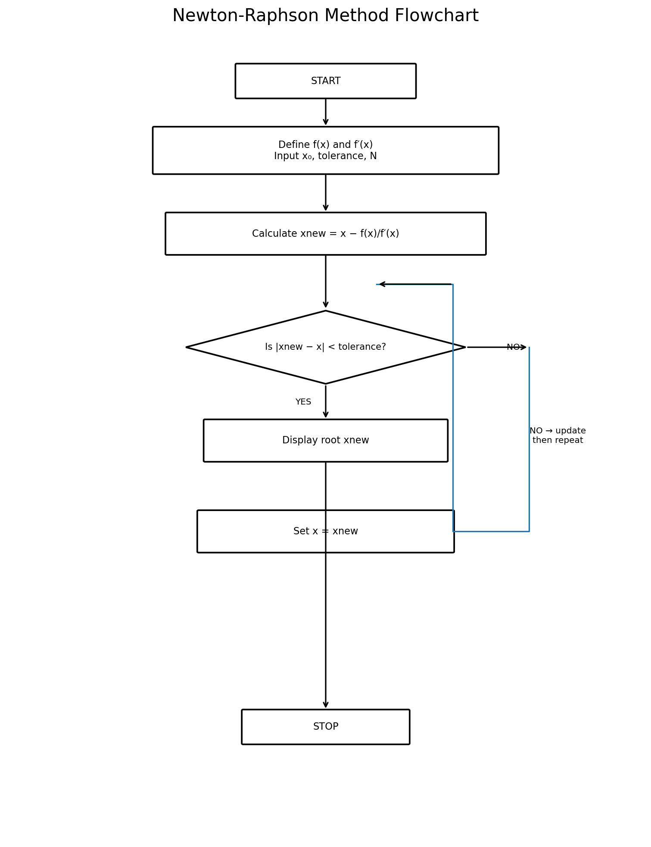

3.6 MATLAB Function – FOR Loop
function root = newtonRaphsonFor(x, tol, N)
f = @(x) x^3 - x - 2;
df = @(x) 3*x^2 - 1;
for i = 1:N
xnew = x - f(x)/df(x);
error = abs(xnew - x);
fprintf('Iteration %d: x = %.6f, Error = %.6f\n', ...
i, xnew, error);
if error < tol
x = xnew;
break;
end
x = xnew;
end
root = x;
end

3.7 MATLAB Function – WHILE Loop
function root = newtonRaphsonWhile(x, tol, maxIter)
f = @(x) x^3 - x - 2;
df = @(x) 3*x^2 - 1;
i = 1;
while i <= maxIter
xnew = x - f(x)/df(x);
error = abs(xnew - x);
fprintf('Iteration %d: x = %.6f, Error = %.6f\n', ...
i, xnew, error);
if error < tol
x = xnew;
break;
end
x = xnew;
i = i + 1;
end
root = x;
end

4. Secant Method

4.1 Question
Find a root of f(x) = x³ − x − 2 using x₀ = 1, x₁ = 2 and a tolerance of 0.0001.

4.2 Formula
xₙ₊₁ = xₙ − [f(xₙ)(xₙ − xₙ₋₁)] / [f(xₙ) − f(xₙ₋₁)]
For f(x) = x³ − x − 2, f(1) = −2 and f(2) = 4. The iterations converge to approximately 1.5214.

4.3 Step-by-Step Calculation
Iteration 1: using xₙ₋₁ = 1.000000 and xₙ = 2.000000, the next approximation is xₙ₊₁ = 1.333333. f(xₙ₊₁) = -0.962963 and the error is 0.666667.
Iteration 2: using xₙ₋₁ = 2.000000 and xₙ = 1.333333, the next approximation is xₙ₊₁ = 1.462687. f(xₙ₊₁) = -0.333339 and the error is 0.129353.
Iteration 3: using xₙ₋₁ = 1.333333 and xₙ = 1.462687, the next approximation is xₙ₊₁ = 1.531169. f(xₙ₊₁) = 0.058626 and the error is 0.068483.
Iteration 4: using xₙ₋₁ = 1.462687 and xₙ = 1.531169, the next approximation is xₙ₊₁ = 1.520926. f(xₙ₊₁) = -0.002693 and the error is 0.010243.
Iteration 5: using xₙ₋₁ = 1.531169 and xₙ = 1.520926, the next approximation is xₙ₊₁ = 1.521376. f(xₙ₊₁) = -0.000020 and the error is 0.000450.
Iteration 6: using xₙ₋₁ = 1.520926 and xₙ = 1.521376, the next approximation is xₙ₊₁ = 1.521380. f(xₙ₊₁) = 0.000000 and the error is 0.000003.
Iteration | xₙ₋₁ | xₙ | xₙ₊₁ | f(xₙ₊₁) | Error
1 | 1.000000 | 2.000000 | 1.333333 | -0.962963 | 0.666667
2 | 2.000000 | 1.333333 | 1.462687 | -0.333339 | 0.129353
3 | 1.333333 | 1.462687 | 1.531169 | 0.058626 | 0.068483
4 | 1.462687 | 1.531169 | 1.520926 | -0.002693 | 0.010243
5 | 1.531169 | 1.520926 | 1.521376 | -0.000020 | 0.000450
6 | 1.520926 | 1.521376 | 1.521380 | 0.000000 | 0.000003
Approximate root: x ≈ 1.521380

4.4 Pseudocode
START
Define f(x) = x^3 - x - 2
Input x0, x1, tolerance and maximum number of iterations
FOR each iteration
Calculate x2 using the Secant formula
Calculate error = |x2 - x1|
IF error < tolerance
Display root
STOP
END IF
Set x0 = x1
Set x1 = x2
END FOR
Display root
STOP

4.5 Flowchart
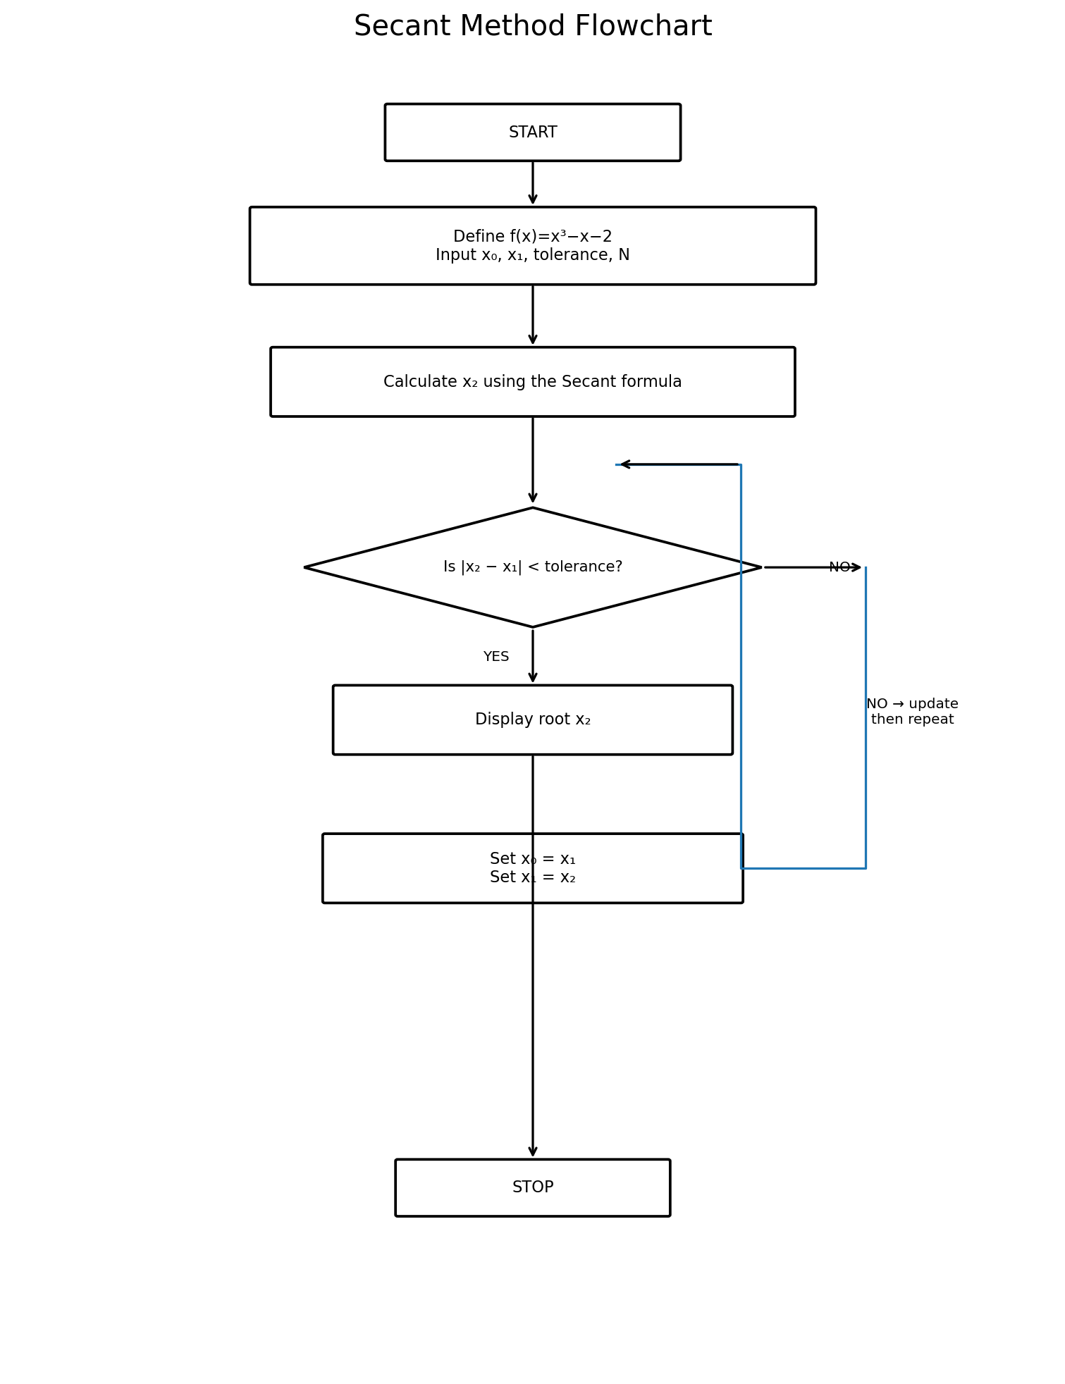

4.6 MATLAB Function – FOR Loop
function root = secantFor(x0, x1, tol, N)
f = @(x) x^3 - x - 2;
for i = 1:N
denominator = f(x1) - f(x0);
if denominator == 0
error('Secant method failed: denominator became zero.');
end
x2 = x1 - (f(x1)*(x1-x0))/denominator;
errorValue = abs(x2-x1);
fprintf('Iteration %d: x = %.6f, Error = %.6f\n', ...
i, x2, errorValue);
if errorValue < tol
break;
end
x0 = x1;
x1 = x2;
end
root = x2;
end

4.7 MATLAB Function – WHILE Loop
function root = secantWhile(x0, x1, tol, maxIter)
f = @(x) x^3 - x - 2;
i = 1;
while i <= maxIter
denominator = f(x1) - f(x0);
if denominator == 0
error('Secant method failed: denominator became zero.');
end
x2 = x1 - (f(x1)*(x1-x0))/denominator;
errorValue = abs(x2-x1);
fprintf('Iteration %d: x = %.6f, Error = %.6f\n', ...
i, x2, errorValue);
if errorValue < tol
break;
end
x0 = x1;
x1 = x2;
i = i + 1;
end
root = x2;
end

5. Runge–Kutta Fourth-Order (RK4) Method

5.1 Question
Solve dy/dx = x + y, with y(0) = 1, using h = 0.1 and find y(0.2) using the fourth-order Runge–Kutta method.

5.2 RK4 Formula
k₁ = h f(xₙ, yₙ)
k₂ = h f(xₙ + h/2, yₙ + k₁/2)
k₃ = h f(xₙ + h/2, yₙ + k₂/2)
k₄ = h f(xₙ + h, yₙ + k₃)
yₙ₊₁ = yₙ + (k₁ + 2k₂ + 2k₃ + k₄)/6

5.3 Step-by-Step Calculation
Step 1: at x = 0.0, y = 1.000000, k₁ = 0.100000, k₂ = 0.110000, k₃ = 0.110500, k₄ = 0.121050. Therefore x becomes 0.1 and y becomes 1.110342.
Step 2: at x = 0.1, y = 1.110342, k₁ = 0.121034, k₂ = 0.132086, k₃ = 0.132638, k₄ = 0.144298. Therefore x becomes 0.2 and y becomes 1.242805.
Step | x | y | k1 | k2 | k3 | k4 | new x | new y
1 | 0.000000 | 1.000000 | 0.100000 | 0.110000 | 0.110500 | 0.121050 | 0.100000 | 1.110342
2 | 0.100000 | 1.110342 | 0.121034 | 0.132086 | 0.132638 | 0.144298 | 0.200000 | 1.242805
Therefore, y(0.2) ≈ 1.242805

5.4 Pseudocode
START
Define f(x,y) = x + y
Input x0, y0, step size h and final x
FOR each step
Calculate k1
Calculate k2
Calculate k3
Calculate k4
Calculate new y
Update x
END FOR
Display final y
STOP

5.5 Flowchart
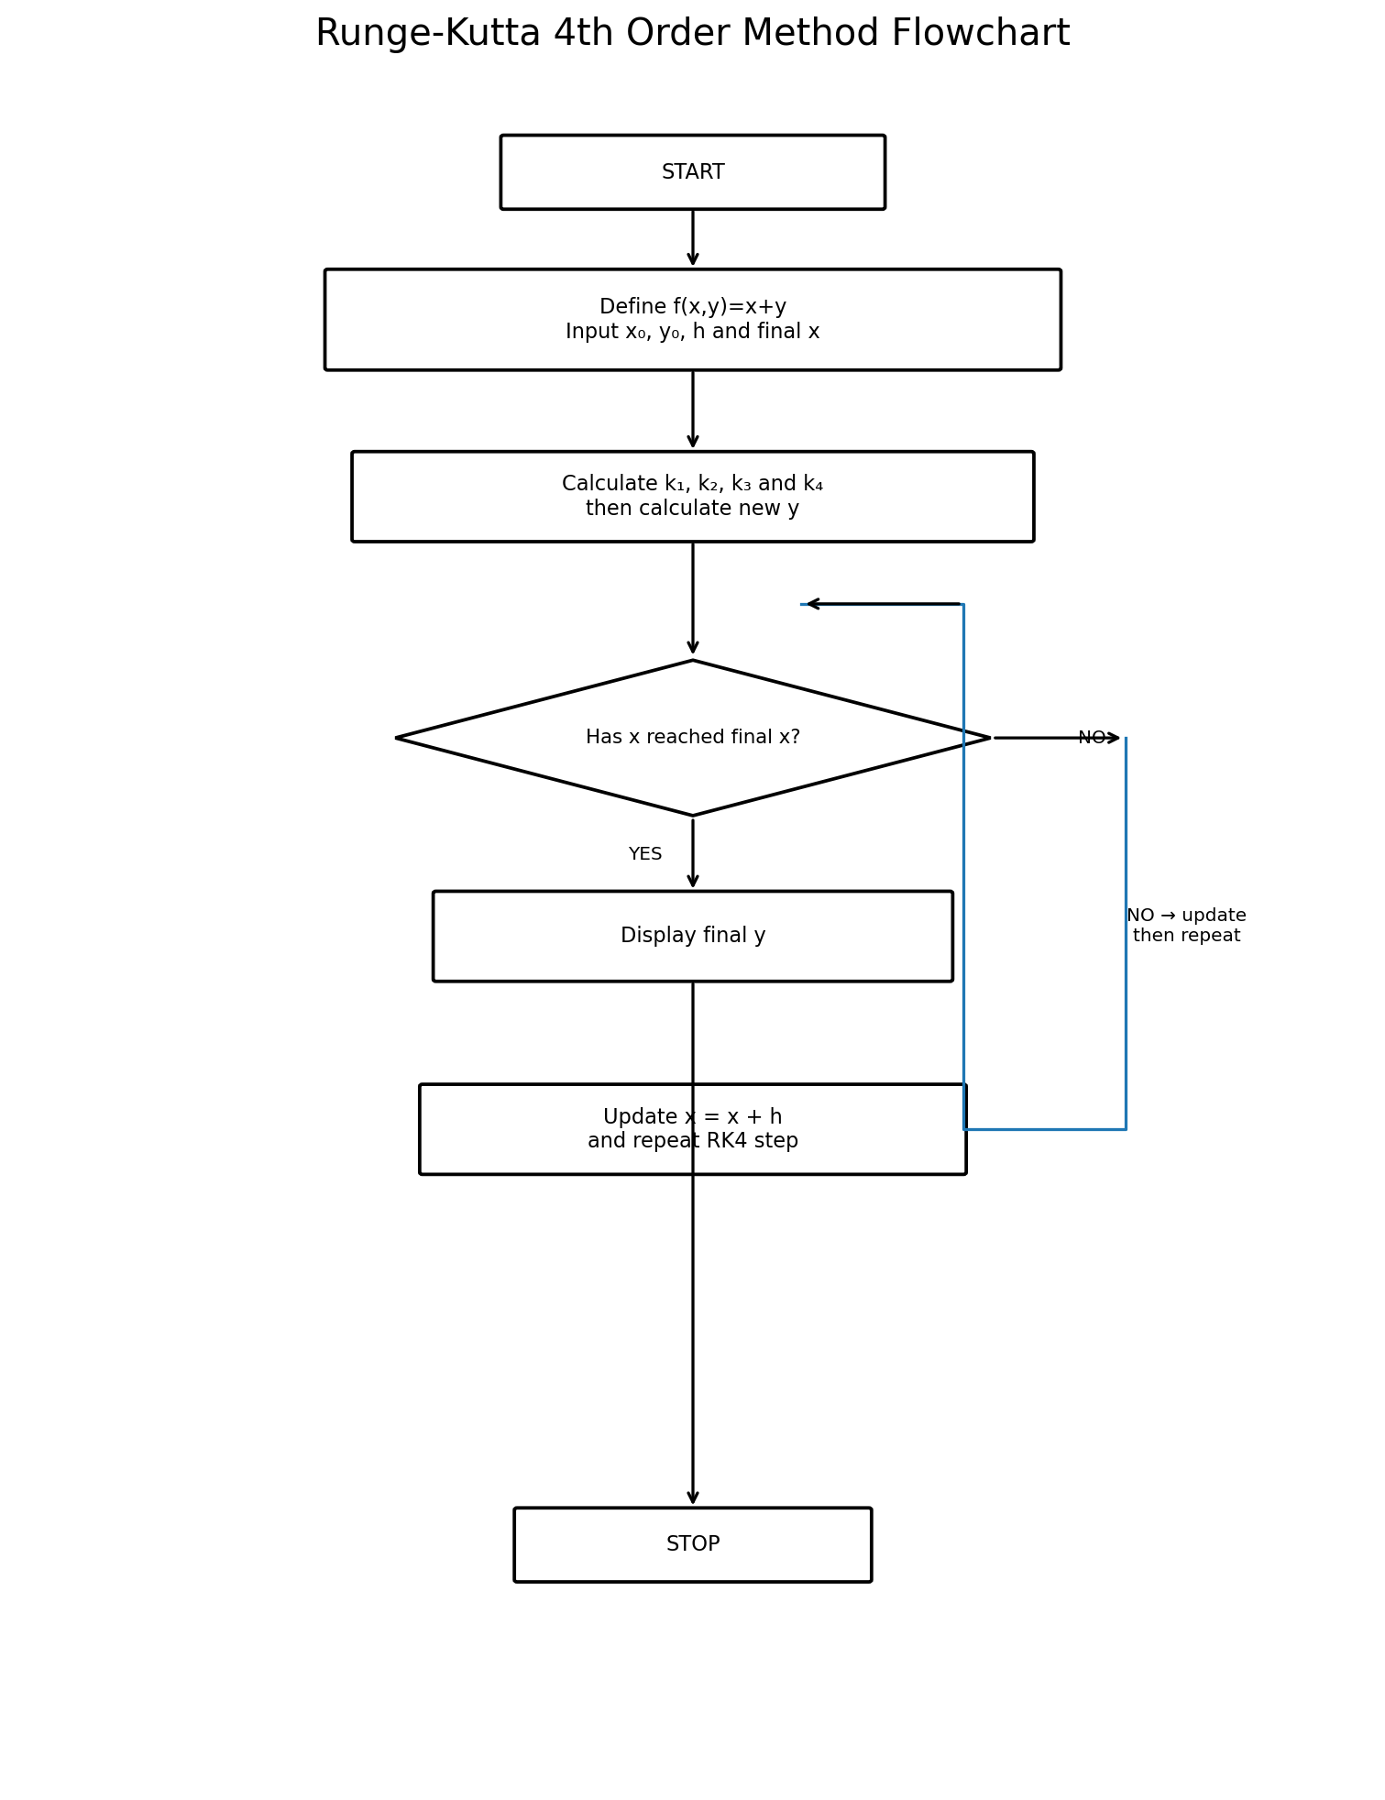

5.6 MATLAB Function – FOR Loop
function [y, x] = RK4For(x, y, h, xend)
f = @(x,y) x + y;
N = round((xend-x)/h);
for i = 1:N
k1 = h*f(x,y);
k2 = h*f(x+h/2,y+k1/2);
k3 = h*f(x+h/2,y+k2/2);
k4 = h*f(x+h,y+k3);
y = y + (k1+2*k2+2*k3+k4)/6;
x = x + h;
fprintf('Step %d: x = %.2f, y = %.6f\n',i,x,y);
end
end

5.7 MATLAB Function – WHILE Loop
function [y, x] = RK4While(x, y, h, xend)
f = @(x,y) x + y;
i = 1;
while x < xend - 1e-12
k1 = h*f(x,y);
k2 = h*f(x+h/2,y+k1/2);
k3 = h*f(x+h/2,y+k2/2);
k4 = h*f(x+h,y+k3);
y = y + (k1+2*k2+2*k3+k4)/6;
x = x + h;
fprintf('Step %d: x = %.2f, y = %.6f\n',i,x,y);
i = i + 1;
end
end

6. Complete MATLAB Program
The following single MATLAB file combines the three methods. Save it as numerical_methods_assignment.m. The first function is the main function, and the remaining functions are local functions.
function numerical_methods_assignment
% NUMERICAL_METHODS_ASSIGNMENT
% Numerical Methods Assignment using MATLAB functions.
% Methods: Newton-Raphson, Secant, and Runge-Kutta 4th Order.
%
% The main function calls local functions. Each method is implemented
% in both FOR-loop and WHILE-loop versions.
clc;
clear;
fprintf('=============================================\n');
fprintf(' NUMERICAL METHODS ASSIGNMENT\n');
fprintf('=============================================\n\n');
fprintf('1. NEWTON-RAPHSON METHOD - FOR LOOP\n');
root1 = newtonRaphsonFor(1.5, 0.0001, 20);
fprintf('Root = %.6f\n\n', root1);
fprintf('2. NEWTON-RAPHSON METHOD - WHILE LOOP\n');
root2 = newtonRaphsonWhile(1.5, 0.0001, 20);
fprintf('Root = %.6f\n\n', root2);
fprintf('3. SECANT METHOD - FOR LOOP\n');
root3 = secantFor(1, 2, 0.0001, 20);
fprintf('Root = %.6f\n\n', root3);
fprintf('4. SECANT METHOD - WHILE LOOP\n');
root4 = secantWhile(1, 2, 0.0001, 20);
fprintf('Root = %.6f\n\n', root4);
fprintf('5. RUNGE-KUTTA 4TH ORDER - FOR LOOP\n');
[yFor, xFor] = RK4For(0, 1, 0.1, 0.2);
fprintf('y(%.1f) = %.6f\n\n', xFor, yFor);
fprintf('6. RUNGE-KUTTA 4TH ORDER - WHILE LOOP\n');
[yWhile, xWhile] = RK4While(0, 1, 0.1, 0.2);
fprintf('y(%.1f) = %.6f\n', xWhile, yWhile);
end
% =========================================================
% NEWTON-RAPHSON: FOR LOOP
% =========================================================
function root = newtonRaphsonFor(x, tol, N)
f = @(x) x^3 - x - 2;
df = @(x) 3*x^2 - 1;
for i = 1:N
xnew = x - f(x)/df(x);
error = abs(xnew - x);
fprintf('Iteration %d: x = %.6f, Error = %.6f\n', ...
i, xnew, error);
if error < tol
x = xnew;
break;
end
x = xnew;
end
root = x;
end
% =========================================================
% NEWTON-RAPHSON: WHILE LOOP
% =========================================================
function root = newtonRaphsonWhile(x, tol, maxIter)
f = @(x) x^3 - x - 2;
df = @(x) 3*x^2 - 1;
i = 1;
while i <= maxIter
xnew = x - f(x)/df(x);
error = abs(xnew - x);
fprintf('Iteration %d: x = %.6f, Error = %.6f\n', ...
i, xnew, error);
if error < tol
x = xnew;
break;
end
x = xnew;
i = i + 1;
end
root = x;
end
% =========================================================
% SECANT METHOD: FOR LOOP
% =========================================================
function root = secantFor(x0, x1, tol, N)
f = @(x) x^3 - x - 2;
for i = 1:N
denominator = f(x1) - f(x0);
if denominator == 0
error('Secant method failed: denominator became zero.');
end
x2 = x1 - (f(x1)*(x1 - x0))/denominator;
errorValue = abs(x2 - x1);
fprintf('Iteration %d: x = %.6f, Error = %.6f\n', ...
i, x2, errorValue);
if errorValue < tol
break;
end
x0 = x1;
x1 = x2;
end
root = x2;
end
% =========================================================
% SECANT METHOD: WHILE LOOP
% =========================================================
function root = secantWhile(x0, x1, tol, maxIter)
f = @(x) x^3 - x - 2;
i = 1;
while i <= maxIter
denominator = f(x1) - f(x0);
if denominator == 0
error('Secant method failed: denominator became zero.');
end
x2 = x1 - (f(x1)*(x1 - x0))/denominator;
errorValue = abs(x2 - x1);
fprintf('Iteration %d: x = %.6f, Error = %.6f\n', ...
i, x2, errorValue);
if errorValue < tol
break;
end
x0 = x1;
x1 = x2;
i = i + 1;
end
root = x2;
end
% =========================================================
% RUNGE-KUTTA 4TH ORDER: FOR LOOP
% =========================================================
function [y, x] = RK4For(x, y, h, xend)
f = @(x,y) x + y;
N = round((xend - x)/h);
for i = 1:N
k1 = h*f(x,y);
k2 = h*f(x + h/2, y + k1/2);
k3 = h*f(x + h/2, y + k2/2);
k4 = h*f(x + h, y + k3);
y = y + (k1 + 2*k2 + 2*k3 + k4)/6;
x = x + h;
fprintf(['Step %d: x = %.2f, k1 = %.6f, k2 = %.6f, ' ...
'k3 = %.6f, k4 = %.6f, y = %.6f\n'], ...
i, x, k1, k2, k3, k4, y);
end
end
% =========================================================
% RUNGE-KUTTA 4TH ORDER: WHILE LOOP
% =========================================================
function [y, x] = RK4While(x, y, h, xend)
f = @(x,y) x + y;
i = 1;
while x < xend - 1e-12
k1 = h*f(x,y);
k2 = h*f(x + h/2, y + k1/2);
k3 = h*f(x + h/2, y + k2/2);
k4 = h*f(x + h, y + k3);
y = y + (k1 + 2*k2 + 2*k3 + k4)/6;
x = x + h;
fprintf(['Step %d: x = %.2f, k1 = %.6f, k2 = %.6f, ' ...
'k3 = %.6f, k4 = %.6f, y = %.6f\n'], ...
i, x, k1, k2, k3, k4, y);
i = i + 1;
end
end

7. Expected MATLAB Results
Method / implementation | Expected result
Newton–Raphson – FOR | Root ≈ 1.521380
Newton–Raphson – WHILE | Root ≈ 1.521380
Secant – FOR | Root ≈ 1.521380
Secant – WHILE | Root ≈ 1.521380
RK4 – FOR | y(0.2) ≈ 1.242805
RK4 – WHILE | y(0.2) ≈ 1.242805

8. Conclusion
The Secant and Newton–Raphson methods were used to obtain an approximate root of f(x) = x³ − x − 2. Both methods converge to approximately 1.52138. The Newton–Raphson method uses the derivative, whereas the Secant method uses two previous approximations instead of explicitly requiring a derivative.
The fourth-order Runge–Kutta method was used to solve dy/dx = x + y with y(0) = 1 and h = 0.1. The calculated value at x = 0.2 is approximately 1.242805. All three methods were implemented using MATLAB functions, with both for-loop and while-loop versions included.

9. References
1. Chapra, S. C. & Canale, R. P., Numerical Methods for Engineers.
2. Burden, R. L. & Faires, J. D., Numerical Analysis.
3. MATLAB documentation and classroom numerical-methods notes.

